

**TATA Motors**

**Requirements Management & Design Verification (RMDV)**

**IBM Rational DOORS Administration Guidance**

Document History

Document Location

This is a snapshot of an on-line document. Paper copies are valid only on the day they are printed. Refer to the author if you are in any doubt about the currency of this document.

Revision History

|  |  |  |  |
| --- | --- | --- | --- |
| **Revision** | **Date** | **Summary of Changes** | **Status** |
| 0.1 | 06/07/16 | First Draft | Draft |
|  |  |  |  |
|  |  |  |  |
|  |  |  |  |
|  |  |  |  |
|  |  |  |  |

Approvals

|  |  |  |
| --- | --- | --- |
| **Name** | **Title** | **Function** |
| Rik Davis | Project Leader | TML |
|  |  |  |
|  |  |  |
|  |  |  |
|  |  |  |

Distribution

|  |  |  |
| --- | --- | --- |
| **Name** | **Title** | **Function** |
| Seth Peacock | ESO Manager | TML |
| Pranav Gangajaliwale | RMDV Administrator | TTL |
| Vivek Dube | RMDV Administrator | TTL |
|  |  |  |
|  |  |  |

Contents

1. Project 5

1.1 Overview 5

1.2 Project Goals 5

1.3 Document Purpose 5

1.4 RMDV Logical Data Model 6

2. Rational DOORS 7

2.1 Citrix Login 7

2.2 Physical Data Model 7

2.3 Mailbox Function 7

2.4 Database Structure 8

2.5 Project Structure 8

2.6 Folder Structure 9

2.7 Module Structure and Attributes 10

2.7.1 Module Views 10

3. Programme Setup 11

3.1 Baseline Generics 11

3.2 Create copy of Generic Project 14

3.3 Temporarily remove access to non-Admins 16

3.4 Upload the RTC categories to filedAgainst in Project Configuration 18

3.4.1 Preparation 19

3.4.2 Import process 20

3.5 Set up RTC configuration 22

3.5.1 Remote Services 22

3.5.2 Define the Configuration Template 26

3.5.3 Set up RTC Module configuration 28

3.6 Copy RTC Configuration to ALL requirements modules. 31

3.7 Import groups in to RDS 33

3.8 Import VPC into ‘Variants for input’ module 39

3.9 Propagate the variant information to the Project Configuration 41

3.10 Add the RDS group prefix to Project Configuration 42

3.11 Run ‘Programme Creation’ 44

3.12 Test to ensure the programme is set up correctly 46

3.12.1 Test to ensure links to Generic Requirements are intact 46

3.12.2 Test to ensure access rights have been correctly applied. 47

3.12.3 Test to ensure triggers have been applied correctly. 48

3.12.4 Test to ensure links to RTC work correctly 50

3.12.5 Clean up test requirements. 51

3.13 Restore access rights 52

4. User Groups 54

4.1 DB Admins 54

4.2 Generic Author 54

4.3 RMDV Administrator 54

4.4 Program Admin 54

4.5 RMDV Contributor 54

4.6 RMDV Reviewer 54

5. DXL 55

5.1 Project Addins 55

5.1.1 User addins 55

5.1.2 Admin addins 55

5.2 Module Addins 56

5.2.1 Admin addins 56

5.2.2 User Addins 56

5.2.3 Non-RMDV specific addins 57

# Project

## Overview

The purpose of the TATA Requirements Management and Design Verification (RMDV) project is to deploy a best in class Requirements Management and Verification System into TATA Motor vehicle programmes.

The project focusses on the configuration of IBM Rational applications and business processes based on the Jaguar Land Rover RMDV standard. This approach will enable an auditable approach standards based requirements, similar to those managed by JLR today, furthermore it will track requirement and testing progress against targets and quality throughout vehicle programmes.

## Project Goals

The overall business goals for this project can be listed as follows:

1. A single approach to requirements management, test verification and design validation for all new TATA Motors vehicle programmes.
2. The re-use of generic TATA Requirements and Test cases.
3. A scalable data model that can support the expansion of RMDV within TATA Motors.
4. Improvement in the accuracy of current requirement and testing project status reporting on vehicle programmes
5. The re-use and traceability of requirements and test cases across vehicle programmes.
6. The phased removal of manual processes from the business and the migration of all requirements and testing artefacts into the RMDV solution.
7. The deployment of the Rational Software Platform to replace current manual and ad-hoc processes based on the JLR Requirements Management and Design Verification system

## Document Purpose

This document will detail the steps required to administer IBM Rational DOORS within the context of the RMDV solution. This is primarily focused on how to set up a new project, from creating the project, to setting up the programme specific settings and activating variants/teams.

This document will also cover uploading new generic requirements from a CSV file and the functions contained within the RMDV Utilities > Admin menus.

.

## RMDV Logical Data Model

Shown for reference purposes only:

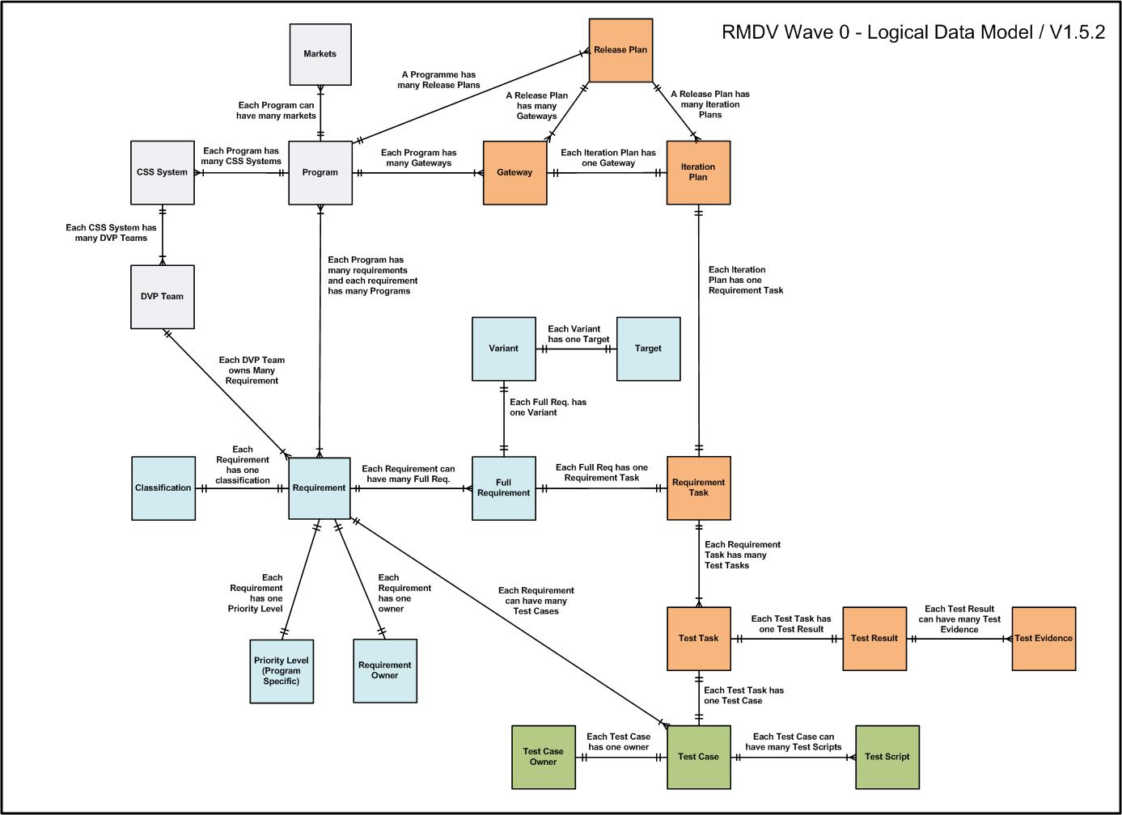

Figure 1 - RMDV Logical Data Model

# Rational DOORS

## Citrix Login

The IBM Rational DOORS application is accessed through Citrix Storefront, the login URL is here: <https://tmlcitrix.clm.ibmcloud.com/Citrix/TataMotorsWeb/>

This will present the Netscaler Gateway login dialogue, login with your credentials.

A successful login will result in the Citrix Storefront being displayed, IBM Rational DOORS Production can be accessed here by clicking on the icon.

## Physical Data Model

Shown for reference purposes only:



Figure 2 - DOORS Physical Data Model

## Mailbox Function

The mailbox has a high administration cost due to its bespoke design. For this reason, the mailbox functional scripts will be installed in the TATA Motors RMDV solution, but the functionality will not be enabled.

Users will use the standard as-designed processes in the DOORS application for the distribution and transfer of requirements. This is in-line with recommended DOORS best practice.

## Database Structure

The DOORS database is set up with two main folders:

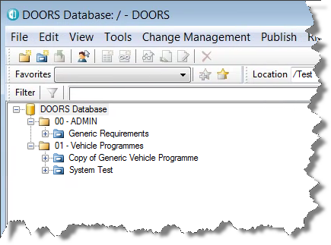

01 – Vehicle Programmes – Vehicle programmes are copies of the Generic Requirements for a specific vehicle programme.

00 – ADMIN – contains the Generic Requirements

Generic Requirements is the base DOORS project from which all vehicle programmes are based. The Generic Requirements project typically contains the 150% of all vehicle requirements. Some requirements may not be needed on some projects i.e. a requirement on diesel particulate emissions would not be applicable in an electric vehicle project.

Individual vehicle programmes are copied from the Generic Requirements and all standard requirements are linked from the Generic Requirements to the vehicle specific copy.

## Project Structure

As each vehicle programme is a copy of the Generic Requirements project, the project structure is identical for every vehicle programme.

There are the same number of folder and the naming is always the same.

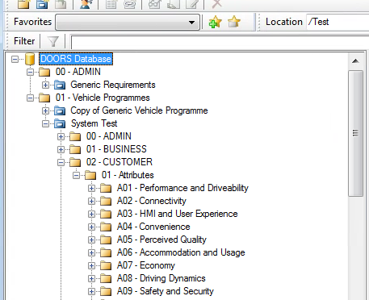

The lowest level of folder is specific to a team, in this case the Attribute team A04 – Convenience.

Yellow folders are used to organise and structure as you would in Windows Explorer. Folders are identical in every project.

Blue folders are DOORS Projects – typically used in RMDV for vehicle programmes

## Folder Structure

Within every Attribute team folder (i.e. A13 – Climate and Comfort) there is a standard set of DOORS modules. DOORS modules come in two main varieties: Formal modules and Link modules. The Formal module is used to contain information such as requirements, variants etc. Link modules contain traceability information between objects that are contained in Formal modules i.e. linking a generic requirement to the programme requirements.

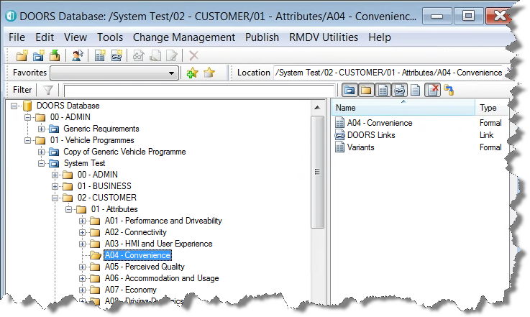

A04 Variants module – used as part of the admin process to create variants for the project.

DOORS Links module – used to link the A04 requirements to the Generic Requirements A04 requirements.

A04 – Convenience requirements – formal module

## Module Structure and Attributes

The structure of the modules in the Generic Requirements project are all driven by the owner of that Attribute and as such could well be different across Attribute teams. Each vehicle programme though will be consistent with the Generic Requirements.

Modules contain individual rows of information called Objects. These objects have metadata (called attributes) which define each object. An example would be the attribute Object Type which is used to identify if a particular object is a Heading, Information or Requirement.

The full list of module/object attributes is defined in the Solution Design document.

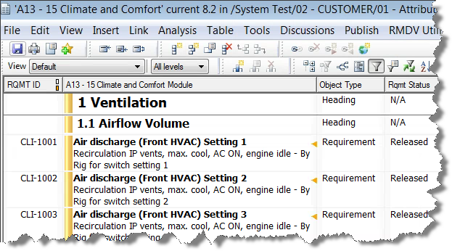

Attributes

Objects

### Module Views

Views are used to define a particular set of attributes to be displayed and possibly to filter the data to show a subset of data i.e. [Object Type == “Requirement”] would only show requirements and not any other type.

There are a standard set of views for Requirements modules. These are defined in the Generic Requirements project and copied with every new vehicle programme. It is perfectly acceptable to have newer vehicle programmes that have different views as the business needs are clarified and evolve.

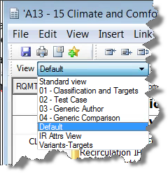

Views

View selector

# Uploading New Generic Requirements

The easiest way to bulk upload requirements for RMDV is via a csv spreadsheet. Generally, this is only required when either doing an initial upload or a bulk update. In the case of RMDV it would be one of the methods to get generic requirements in to the system for DVP Teams that do not currently have any data loaded. Once a DVP Team has data loaded, the recommended method is the Generic Author user for that team performs the update in DOORS.

The business will need to provide the spreadsheet of generic requirements.

1. Open the spreadsheet from the business
2. Verify the column titles – the titles should match the columns in the view 03 – Generic Author with the main column being Object Text.
3. Save it as a CSV
4. Open the relevant module in the /Generic Requirements project in Exclusive Edit
5. From the module menu, select File > Import > Spreadsheet
6. Browse to the csv file you need to import
7. Click Import (NOTE: There should not be a prompt to create a new attribute if you have got the correct column titles. If you do get a prompt, go back to the spreadsheet and correct the anomaly.)
8. Verify the data has imported.
9. Restructure the module so that requirements are children of the headings and that the heading levels are correct.
10. Verify the module against the spreadsheet.

# Programme Setup

There are a number of steps required to set up a new vehicle programme, these are summarised below and will be expanded upon within this section:

1. Baseline Generics
2. Create copy of Generic project
3. Temporarily turn access off at the top level for non-admins
4. Upload filedAgainst information to Project Configuration module
5. Setup RTC configuration on RTC Configuration module
6. Copy RTC configuration across to all Requirements modules
7. Ensure new groups are setup in RDS
8. Import VPC into ‘Variants for input’ module
9. Run ‘Add variant information to configuration module’ function to propagate information to Project configuration
10. Add the RDS group prefix to project configuration module
11. Run ‘createprogramme’ function
12. Test to ensure links to generic are intact
13. Test to ensure access has been correctly applied
14. Test to ensure links to RTC work correctly
15. Test to ensure triggers applied correctly
16. Restore the access rights at the top level.

## Baseline Generics

The first step of the new vehicle programme creation is to baseline all of the modules in the Generic Requirements project. This gives us a known starting point for that particular vehicle programme.

It is not possible to baseline an entire project in DOORS however there is an administrative script that will iterate through all of the folders in the project and baseline each module as it finds them.

1. To activate the script, navigate to the 00 – Admin folder on the database explorer and click on the Generic Requirements project in the left hand pane. Click on any folder on the right hand side.
2. From the DOORS Database menu, select RMDV Utilities > Admin > Baseline modules in folder

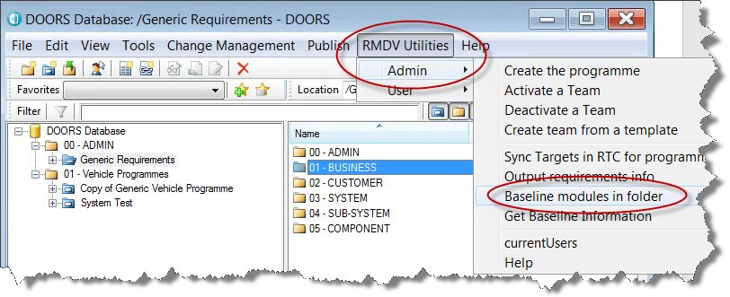

This will present the following dialogue box:

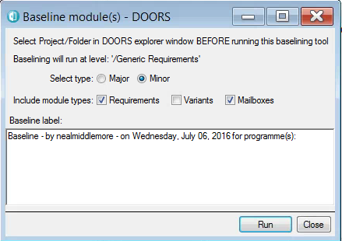

Folder that will be iterated around for the baseline – ENSURE THIS SAYS /Generic Requirements

The parameters needed are:

**Select type:** Major or Minor (default) – DOORS baselines are identified with a major version and a minor version i.e. Major version 8 Minor version 4 would show as 8.4. Minor should be used unless significant changes have been made to Generic Requirements. This would be things like adding new attributes, adding new teams. It would not include modifying views or attribute values.

**Include module types:** Requirements is the only option that is needed here. Mailboxes can be left selected; they are not used in TML RMDV. Variants can be added if the Variants module actually changes, this is VERY rare so is left unselected by default.

**Baseline label:** The baseline label is partially completed, the vehicle programme(s) that are about to be created need to be added to the end of the text i.e. Baseline - by nealmiddlemore - on Wednesday, July 06, 2016 for programme(s): X541, X760

1. Once the settings have been made, click Run in the dialogue box.

Upon completion you will be presented with this dialogue:

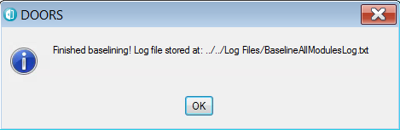

Log File location – REVIEW THIS!

The log files can be accessed from the Windows Explorer icon in the Citrix Storefront after you log in through the Netscaler Gateway. The Windows Explorer window shows the local drives, the internal mapped network drives and your drives.

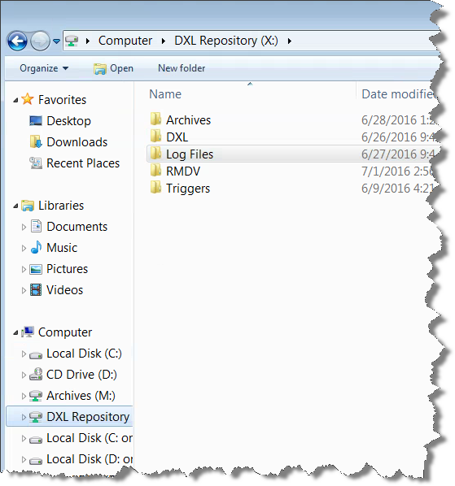

1. Log Files folder
2. DXL Repository mapped drive

Open the BaselineAllModulesLog.txt file

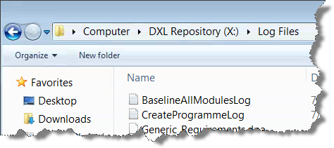

Baseline log file

The log file shows ALL of the baseline activities on both Production and Training environments. The most recent is at the bottom. Check the new baseline entries for errors. There are 18 modules baselined as standard (17 Attribute teams and 1 Empty Generic Module).

This step is now complete.

## Create copy of Generic Project

In order to create the base material for a vehicle programme, the Generic Requirements project must be copied, however using Copy and Paste on Generic Requirements will result in the copying of the outgoing links from Generics to all the other projects.

This is NOT the way to do it. Archive and Restore will break the links to other projects, this is correct way to create a copy of Generic Requirements project.

1. With the 00 – ADMIN folder selected in the left hand pane of the DOORS Database Explorer, click the Generic Requirements project in the RIGHT HAND pane.
2. Select File > Archive – this presents the archive project dialogue box;

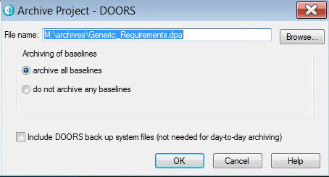

1. If it is not already set, browse to the mapped network drive M: and select the Archives folder.

***IMPORTANT NOTE: Using DOORS in Citrix requires a specific folder to be set up for archiving projects, this environment is set to use M:/Archives. Using ANY OTHER location will result in a corrupted archive that cannot be restored.***

1. Click Ok
2. Click ‘Confirm’ if prompted to overwrite the Generic_Requirements.dpa (This can take several minutes depending on the size of the Generic Requirements project)
3. Navigate to the 01 – Vehicle Programmes directory
4. Select File > Restore > Project
5. Browse to the M:/Archives directory and select the Generic_Requirements.dpa file created at Step 5

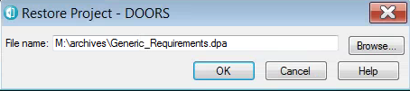

1. Click on Ok
2. Set the New name field to the name of the new vehicle programme:

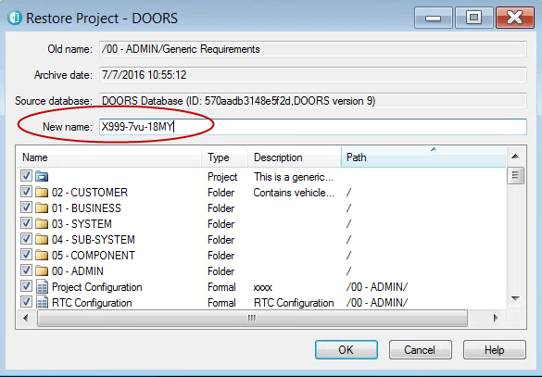

1. Click on OK to create the new project. (This can take several minutes to complete, the bigger the Generic Requirements gets, the longer this step will take. Restore always takes longer than Archive.
2. Verify the new project has been created.

This step is now complete.

## Temporarily remove access to non-Admins

In order to ensure that the project is not accessed by ANYBODY other than the admins before it is ready, it is necessary to remove access. The admins should be members of the DB Admins group (discussed in Section 4).

1. Right click the new project and select Properties.
2. Switch to the Access tab where a list of groups with access is listed:

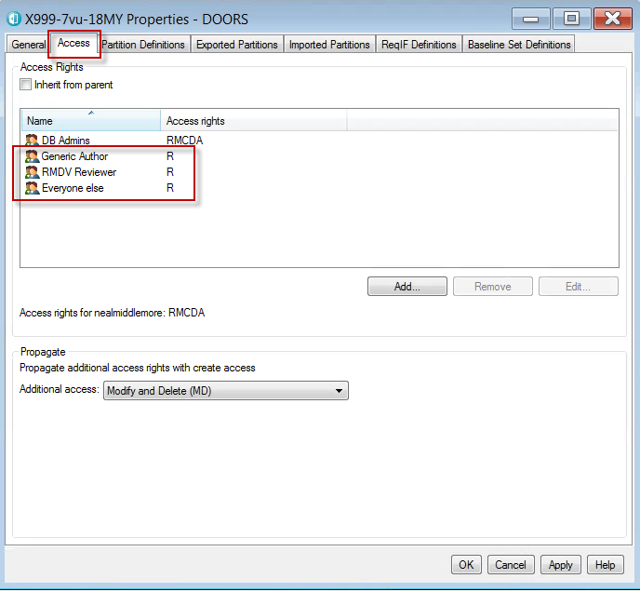

1. Select each group (other than the DB Admins group) in turn. Click the ‘Edit’ button and set the access rights to None. Click Ok on the Edit Access dialogue after each group to save the changes for that group.

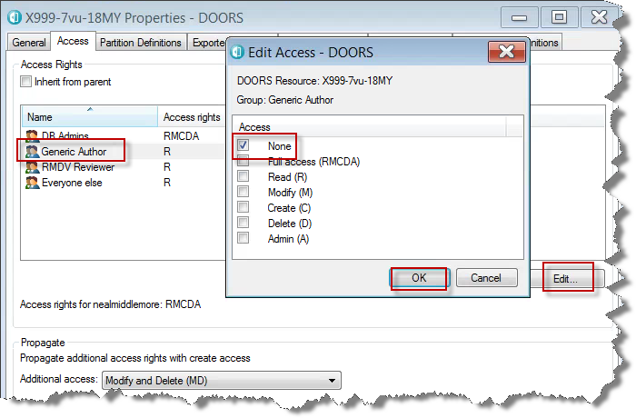

The access rights should now look like this:

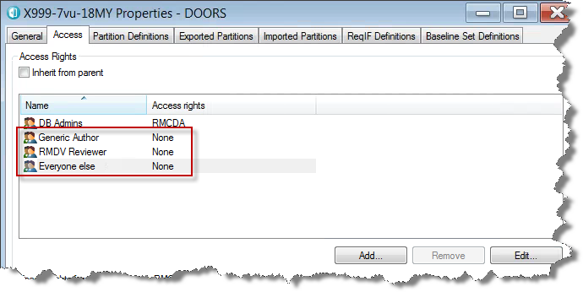

1. Click the OK button on the project properties dialogue to save these changes:

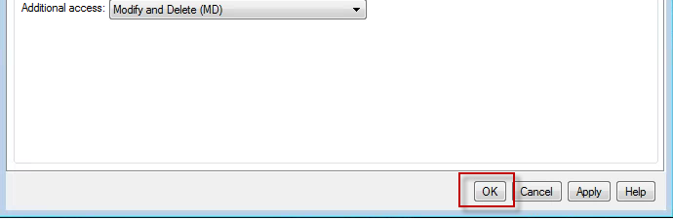

This step is now complete.

## Upload the RTC categories to filedAgainst in Project Configuration

Most of the configuration work for a new project is done in the Project Configuration module in the 00 – ADMIN folder of the new project.

The 00 – ADMIN folder in the project contains a number of important modules for administration.

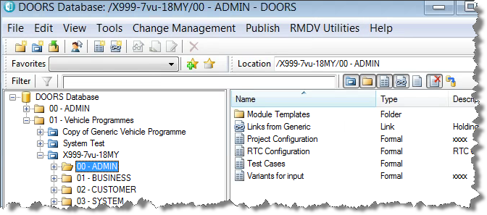

**Project Configuration** – The project configuration module contains the base information required to set the programme up. It holds a list of the DVP Teams i.e. the list of Attribute teams in this case. It records the team names and the prefixes that will be used for those teams such as CLI for A13 – Climate and Comfort. It also holds the filedAgainst attribute:

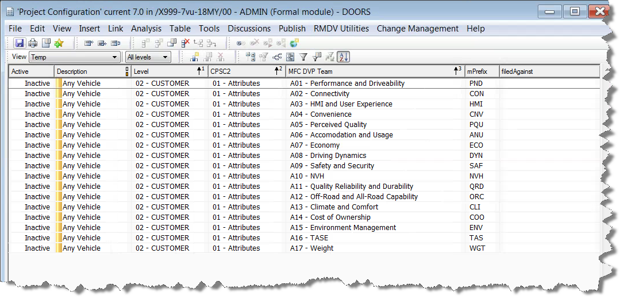

filedAgainst is used by the DOORS – RTC integration to identify exactly which team in RTC these requirements belong to. It is a unique identifier for that team in RTC. As such, it has to be uploaded for each new vehicle programme after the corresponding RTC project has been set up.

The filedAgainst attribute is extracted from RTC, the process to do this will be covered in the RTC Admin training. The output is a spreadsheet called XXXX Programme Setup Report ddmmyyyy.xslx. This spreadsheet has multiple tabs containing information about the project setup such as the list of Teams, Categories, Administrators etc. The important tab for this step is the Categories tab. In RTC, a Category is used to associate a work item with a specific team, the category normally has the same name as the team. PLEASE NOTE: TEAM NAMES IN RTC AND DOORS MUST BE THE SAME

### Preparation

Here is an example spreadsheet:

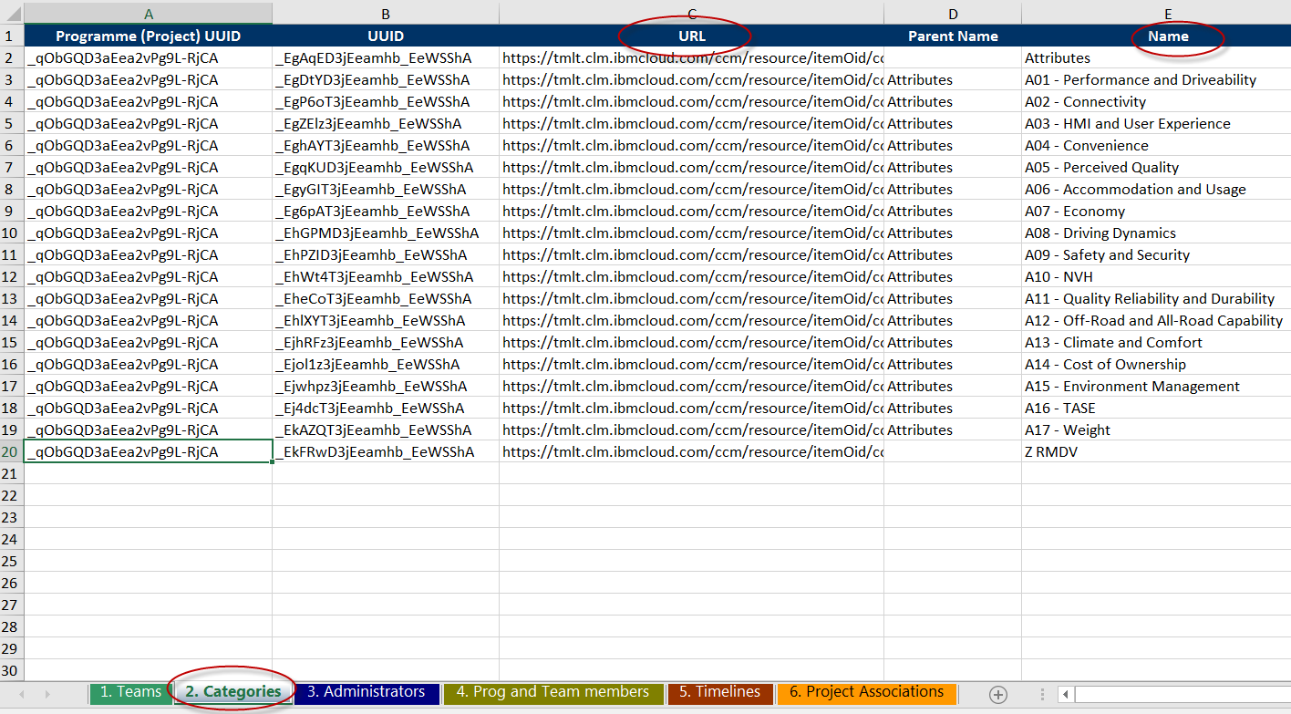

The Categories tab contains multiple columns but we are only interested in two of them, the URL in column C and the Name in column E.

1. Rename Column C from URL to filedAgainst.
2. Rename Column E from Name to MFC DVP Team.
3. Delete the other columns so that you only have filedAgainst and MFC DVP Team left on the Categories tab.
4. SAVE THE SPREADSHEET AS A CSV(comma delimited) FILE. – This saves only the current worksheet as a CSV file.
5. **There will be two rows that we need to delete as well. In the above picture it is the first and last row. The team name for the first row is Attributes, whilst this is genuine category in RTC it isn’t a team name that we want to use in DOORS. The last row is a team called Z RMDV and can also be deleted for the same reason.**
6. Save the csv file.

If you were to close and open the csv file, it would now look like this:

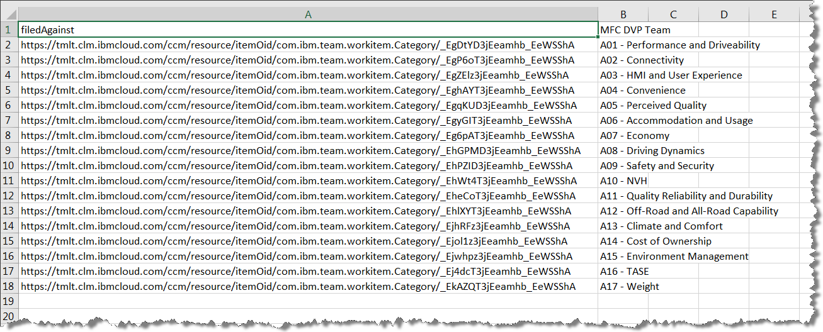

This is now ready to import in to the Project Configuration Module.

### Import process

1. Navigate to the new project 00 – ADMIN folder
2. Open the Project configuration module in Exclusive Edit.
3. Select File > Import > Spreadsheet

This will present the following dialogue box:

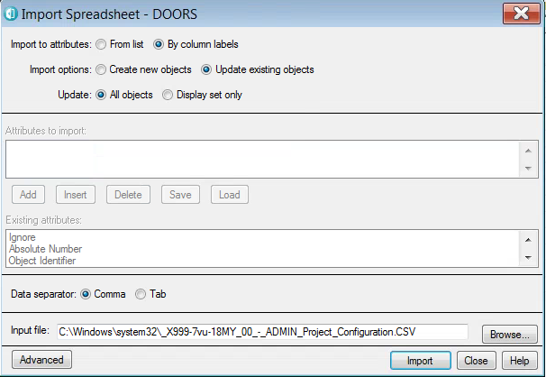

Browse to the csv you have saved.

1. Browse to the csv file you created
2. Click Import
3. Select the MFC DVP Team as the key for import and click Select:

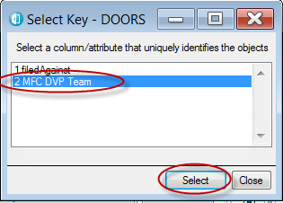

1. Verify that the number of objects updated matches the number of teams, in this case it will be 17.
2. Verify that no new objects were created.
3. Verify that the filedAgainst attribute has been populated from the spreadsheet
4. Save the Project Configuration module.
5. Close the Import Spreadsheet dialogue box.

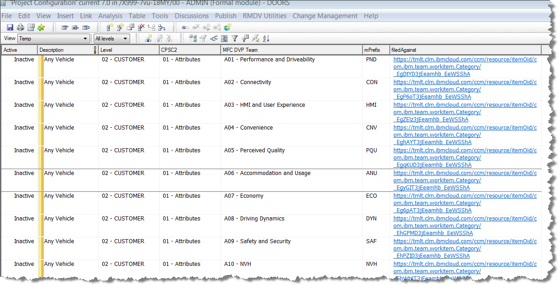

This step is now complete.

## Set up RTC configuration

In order to send data to RTC, the RTC configuration has to be set up. There are several elements to this.

1. Add the correct Remote service link for the new RTC project
2. Define a configuration template to use the correct RTC project
3. Set up the RTC Configuration module in the new vehicle programme

### Remote Services

The Remote Services in DOORS defines which projects and link types can be used between DOORS and RTC/RQM. A new collaboration link has to be established to achieve this. The only two link types used in RMDV are Implemented by and Validated by.

Implemented by is a type of link used with RTC and there will be one of these for every vehicle programme.

Validated by is a type of link used with RQM, there is one of these to link Generic Test Cases to Generic Requirements as well as one for Programme Specific Test Cases. These have already been added as part of the RMDV configuration already performed and should not be modified.

Here is an example of the training database configuration:

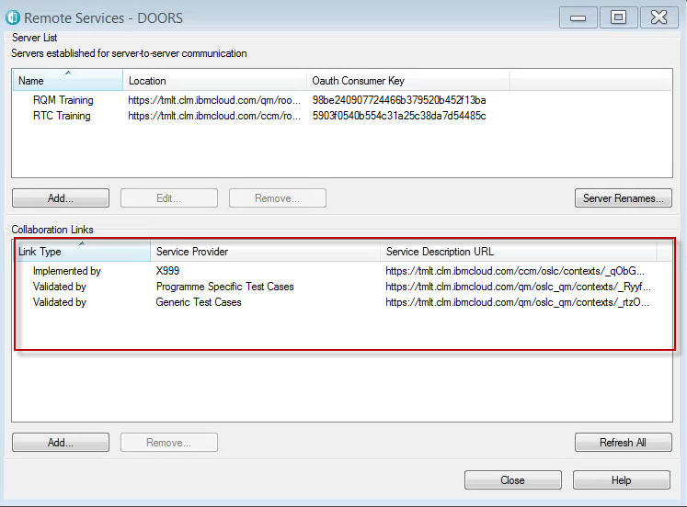

The two Validated by links are used by ALL vehicle programmes and no more of these need to be added. The Implemented by is repeated for each vehicle programme to link to the corresponding RTC project. On the Training DB there is only 1 vehicle programme.

Steps to add the new Implemented by:

1. On the DOORS database explorer, select File > OSLC > Remote Services

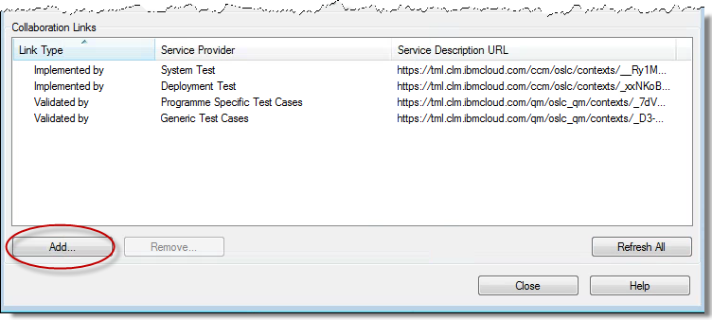

1. Click the Add button
2. From the Server drop down box, select RTC:

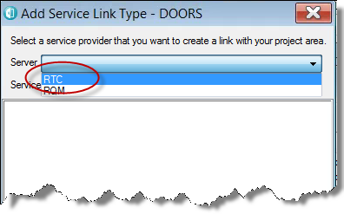

1. If you haven’t already logged in to RTC from DOORS in the current session, you will have to authenticate to RTC (enter user ID/password and click Login):

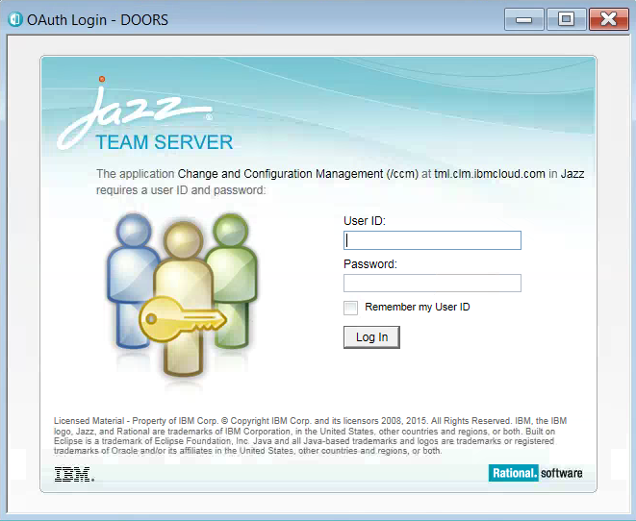

1. Expand the Change Management section and select the correct project.

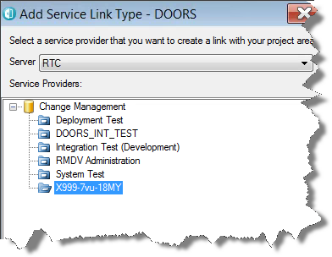

1. In the Link Types box at the bottom, select the Implemented by {PROJECT NAME} line:

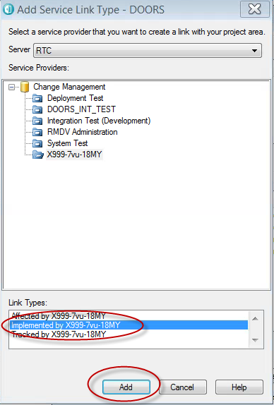

1. Click the Add button to add the Collaboration Link to the new project in RTC.

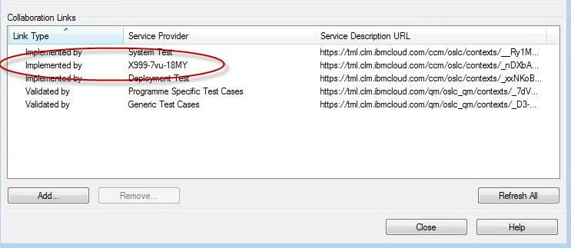

1. Close the Remote Services dialogue box.

This step is now complete.

### Define the Configuration Template

The Configuration Template defines which Collaboration Link to use in any given DOORS module. This will default the module to creating work items in the correct RTC project. There will be a configuration template for every RTC project.

1. In the DOORS Database Explorer window, select Change Management > Define Configuration Templates:

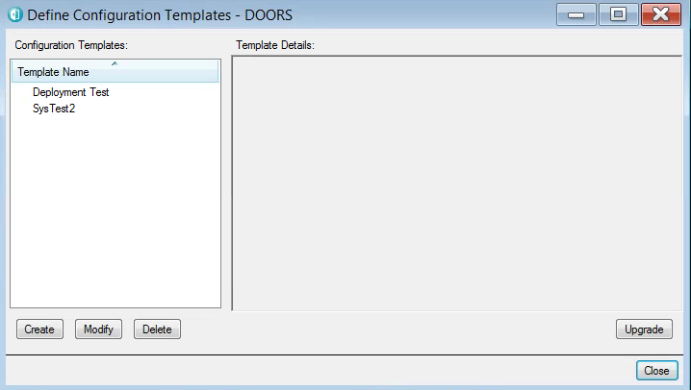

1. Click the Create button on the Define Configuration Templates dialogue box.

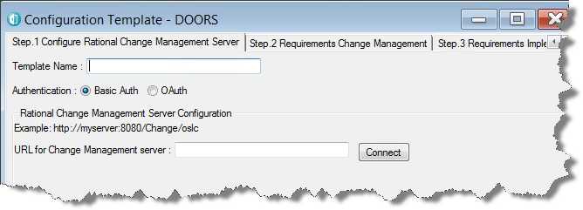

1. In the Template Name box, enter the project name i.e. X999-7vu-18MY
2. Select the OAuth radio button.

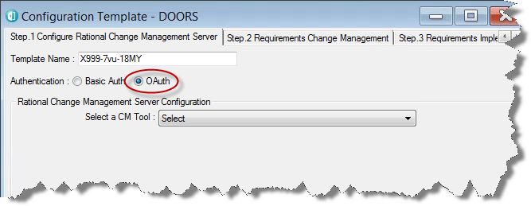

1. Use the drop down to select the RTC project

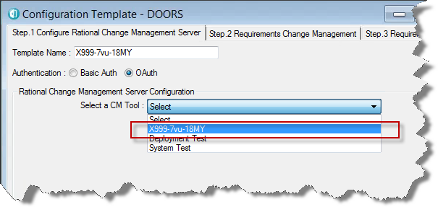

1. Click Next four times to go through to Step 5 Finish. (Steps 2, 3 & 4 are only used when enforcing change management of requirements, this is not used in RMDV)
2. Click Finish:

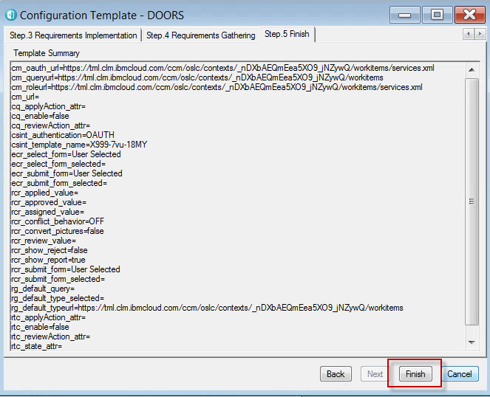

1. Click ‘Close’ on the Define Configuration Templates dialogue box.

This step is now complete.

### Set up RTC Module configuration

Now that the DOORS database is configured to talk to the correct RTC project, each requirements module in the new vehicle programme also has to be configured to send the correct information to a specific RTC project. In the 00- ADMIN folder for the new vehicle programme, there is an RTC Configuration module. This module is configured first and then pushed to all the other modules.

There are two ways to do this operation:

1. Manually – this requires knowing all of the custom attribute names in RTC i.e. in a Requirement Task in RTC, the Target attribute is called: rtc_ext:req_target
2. Using DOORS to copy an existing configuration – This is the easiest and fastest option, use the most recent project prior to the one you are creating as a basis. If any new data needs to be sent to RTC, you will need to manually configure that before copying the configuration out to all the other requirement modules.

This step will show the faster method.

1. In the DOORS Database Explorer window, select Change Management > Copy Module Configuration
2. At the top of the dialogue box, select the Browse button and navigate to the recent project and select a requirements module to copy the configuration from:

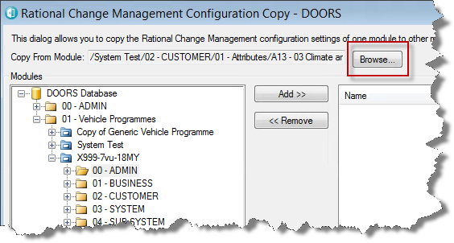

1. In the left hand pane of the dialogue box, navigate to the new vehicle programme/00 – ADMIN and select the RTC Configuration module

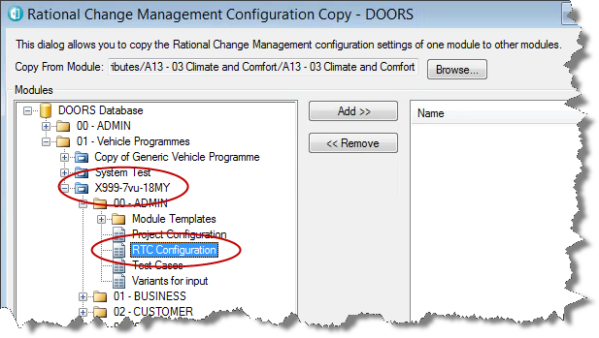

1. Select the Add button to the RTC Configuration module to the right hand pane and click Copy.

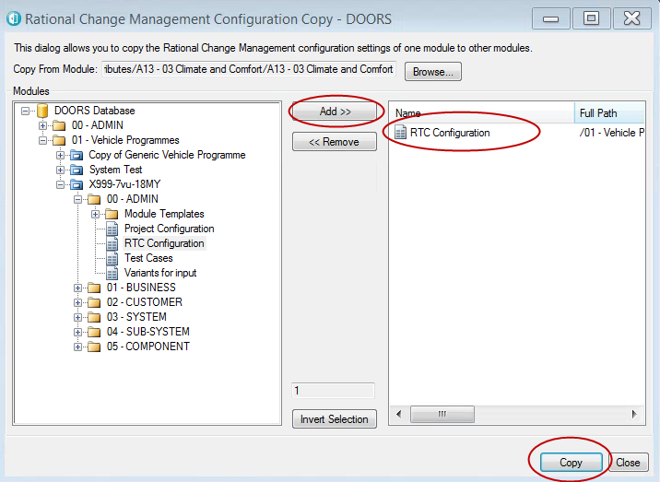

1. Click ‘Confirm’ to copy the configuration.
2. Verify the copy succeded:

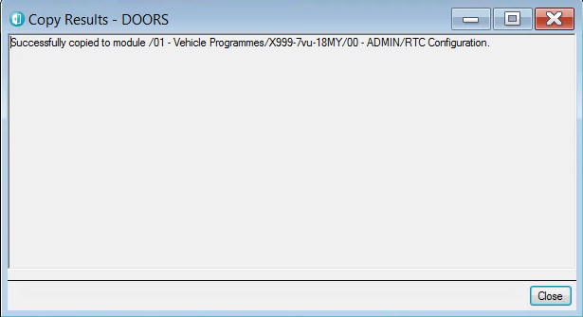

1. Close the Copy Results dialogue box.
2. Open the RTC Configuration module and select Change Management > Configure Module
3. The template name in use will be for the project you copied this from so select the correct project.

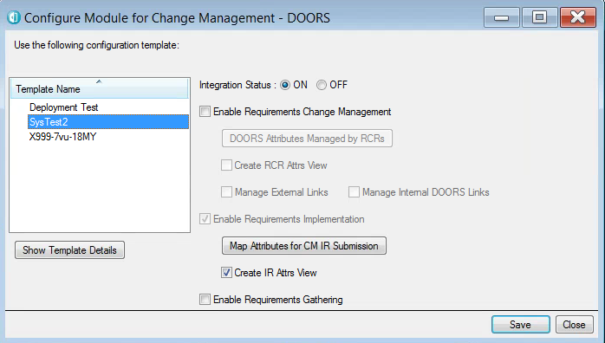

New project configuration template

Project you copied from!

1. Click on the ‘Map Attributes for CM IR Submission’ button
2. Verify the DOORS attributes are still mapped to RTC attributes.

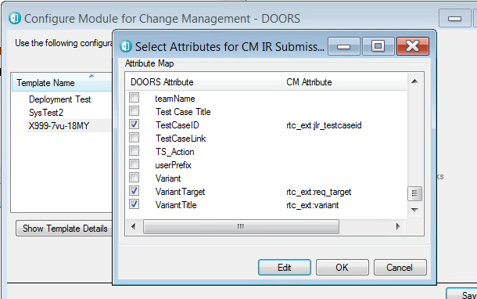

1. Click OK
2. Click Save.

This step is now complete.

## Copy RTC Configuration to ALL requirements modules.

The RTC Configuration module now has the correct set up for this new vehicle programme, this configuration has to be copied to all of the requirements modules so that EVERY requirements module can link to the correct RTC project.

1. In the DOORS Database Explorer window, select Change Management > Copy Module Configuration
2. At the top of the dialogue box, click the Browse button and select the 00 – ADMIN/RTC Configuration module in the new vehicle programme. This is the module we will copy the RTC configuration from.
3. In the left hand pane, navigate to the new vehicle programme and select all of the requirements modules and add them to the right hand pane. Do NOT select the Variants modules.

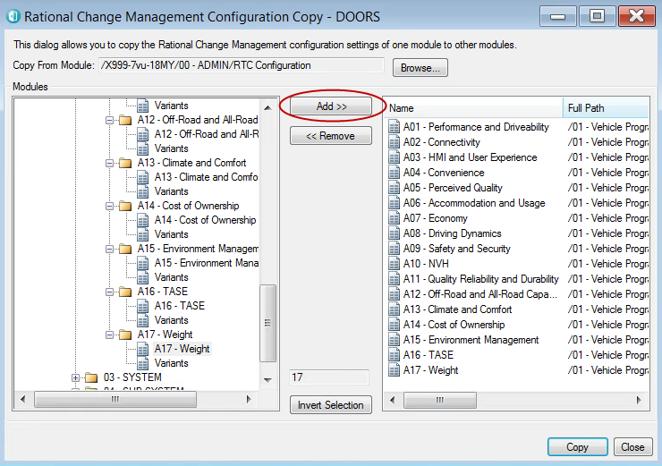

At Phase 1, there are only the 17 Attributes requirements modules to add.

1. Click the Copy button
2. Click ‘Confirm’ to continue with the Copy configuration operation.
3. Verify the Copy operation was successful:

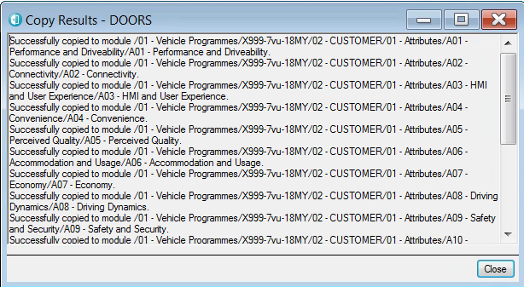

1. Close the Copy Results dialogue box.

This step is now complete.

## Import groups in to RDS

Rational Directory Server (RDS) is used between DOORS and the LDAP to allow the RMDV Administrators to create groups for RMDV without having to create new LDAP groups. The interface for creating groups and adding users from the LDAP to them is Rational Directory Administrator (RDA).

In order for the access rights to be set up correctly, a specific set of groups needs to be created. Specific user groups are discussed in section 4 in more detail.

Every new vehicle programme has a specific Project Admin group and then a RMDV Contributor group for each MFC DVP Team as defined in the Project Configuration module. Every RMDV user also goes in to a group called RMDV Reviewer, this allows read access at the project and folder layer, the user will also be

These groups can be created manually in RDS, but there are 17 MFC DVP Teams plus the Project Admin group so it is faster to manage a list in xml and then import it to RDS.

The XML file template is a predefined format and can be edited in any text editor, the recommendation is Notepad++.

The XML file is formatted as below:

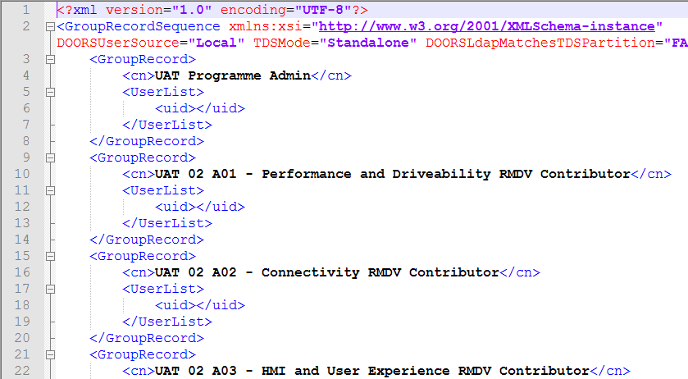

Group type

Team Name

Project name (UAT)

Level (as in 02 – CUSTOMER)

These group names are used by the DXL scripts to set the access right correctly for the new vehicle programme. When using DOORS it is imperative to understand and define the access rights correctly in order to prevent users reading, modifying or deleting data accidentally.

1. With the XML file open, replace all of the project names with the new project name i.e. replace UAT with X999-7vu-18MY.

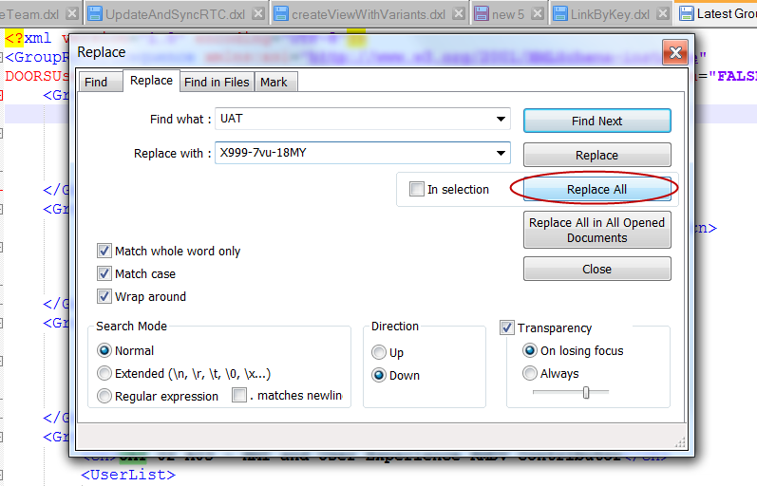

The group names should now reflect the correct project:

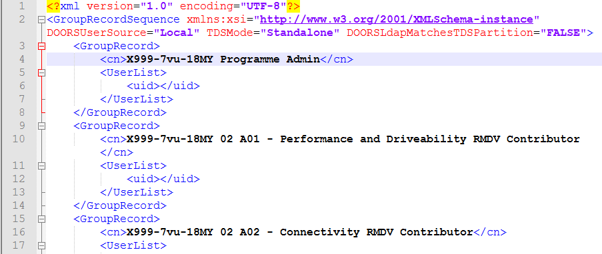

1. Open Rational Directory Administrator – <https://tmlrda.clm.ibmcloud.com:9443/webrda/rda>
2. Login as tdsadmin (this is the ONLY account that can log in to RDS)

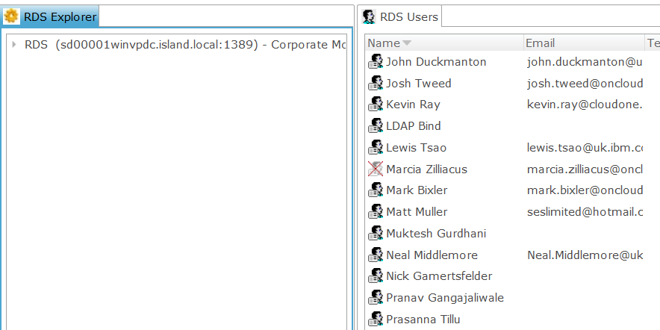

Users from the LDAP (in this case the CloudLDAP)

RDS information – click triangle to expand.

1. Select Console > Migrate

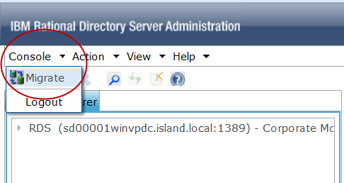

1. Select Group Migration
2. Browse to the groups XML file you created earlier and select Open

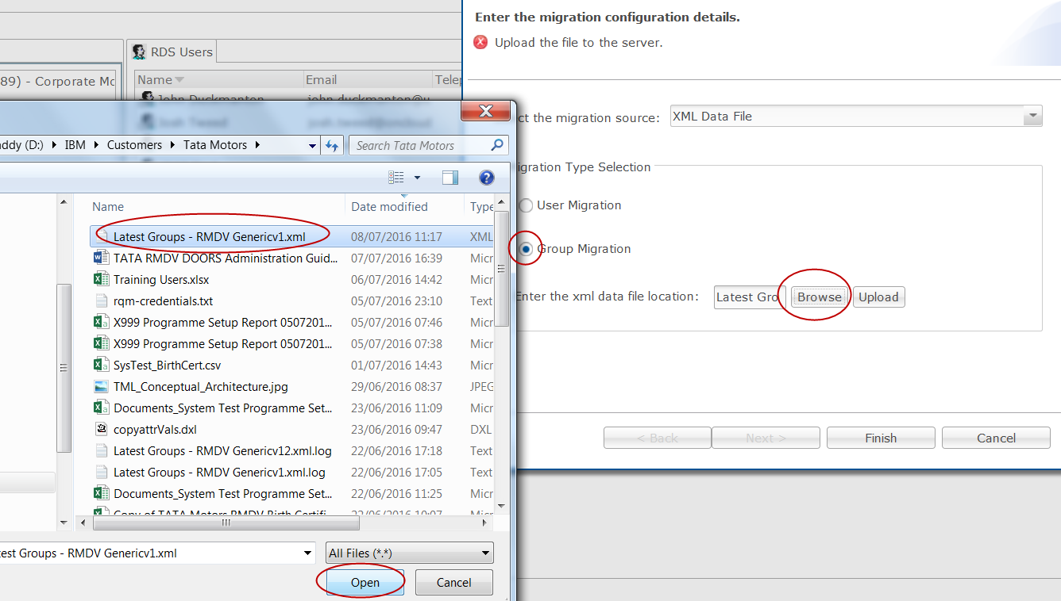

1. Select Upload.
2. Click the OK on the file upload acknowledgement
3. Click Finish – the pre-migration analysis view is now shown

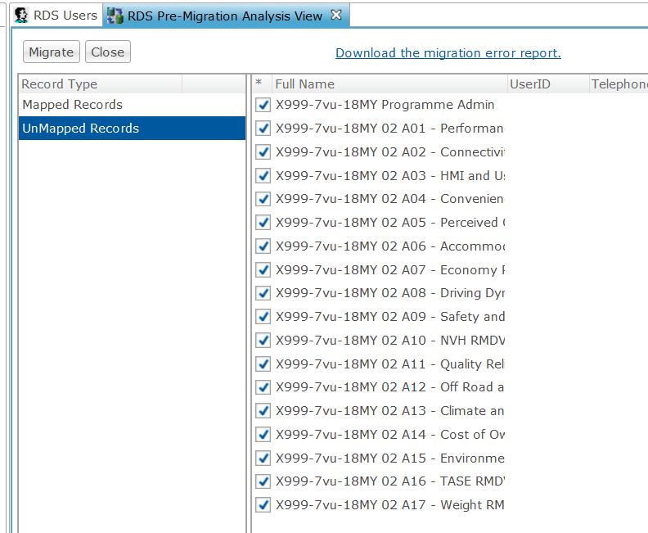

1. Click on Mapped Records – as we are migrating new groups in to RDS, there should be ZERO entries in Mapped Records. If there are entries in the Mapped Records, it means you are trying to import groups that already exist in RDS – Cancel the migration and go back and fix your XML file.
2. Click on UnMapped Records, it should look similar to above – 1 x Programme Admin group and 17 x Attribute team groups.
3. Click Migrate and verify the groups are migrated.

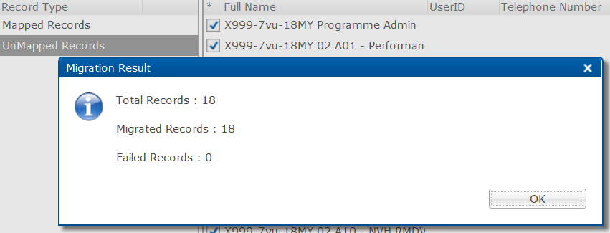

1. Click the OK button on the Migration Result box.
2. Click the Close button on the Pre-Migration Analysis View.
3. Expand the triangle to show the RDS information
4. Expand the triangle next to Groups
5. Select the RDS Groups:

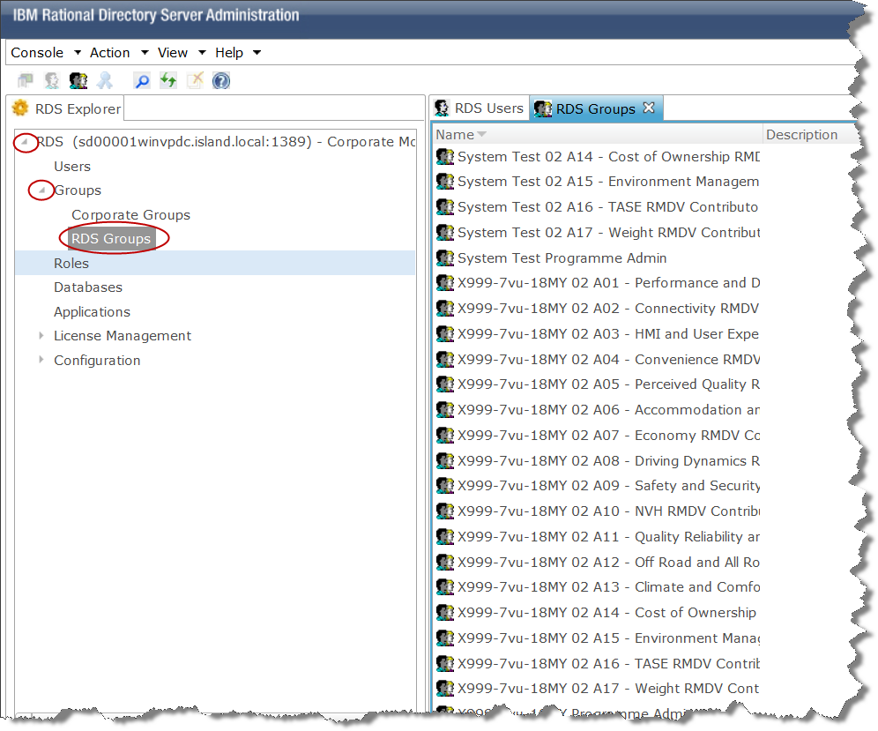

1. Verify the new groups are listed.

This step is now complete.

## Import VPC into ‘Variants for input’ module

Every vehicle programme has one or more variants that the requirements apply to i.e. Any LHD, 1.5 CRAIL Engine, 2.0 CRAIL Engine etc. This information is contained in the Vehicle Programme Certificate (VPC).

The business is responsible for creating the VPC or ‘birth certificate’ for the new vehicle programme. This has to be supplied to the RMDV Administration team to allow them to create the programme correctly. The VPC holds the variants, the teams to which those variants apply and if a team will be active or not in a given programme.

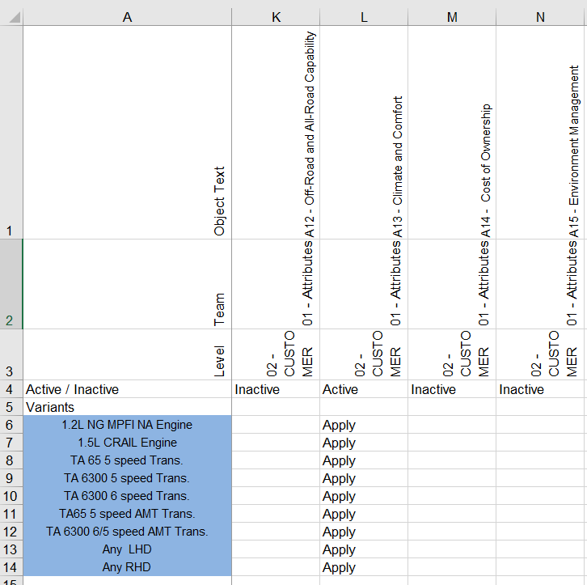

In this example, 02 – Customer/01 – Attributes/A13 – Climate and Comfort team is ACTIVE for this vehicle programme. A12, A14 and A15 are not active. There are also a number of variants listed, all of which apply to the A13 team, however it is normal that not all variants will apply to all teams.

1. Open the VPC and check the data (i.e. Level should a number followed by a name in capital letters)
2. Save the VPC as a csv file. It is worth noting how many teams and variants are in it.
3. Open the Variants for input module in the new vehicle programme 00 – ADMIN folder.
4. Select File > Import > Spreadsheet
5. Leave the default settings and browse to the csv of the VPC.
6. Import the spreadsheet. If there are any prompts to create new attributes then cancel the import and go back to the csv to check the team names are correct.
7. Take a note of the number of objects created and check it matches the number of variants in the csv.
8. Perform a manual check of the module to verify the data is as expected.

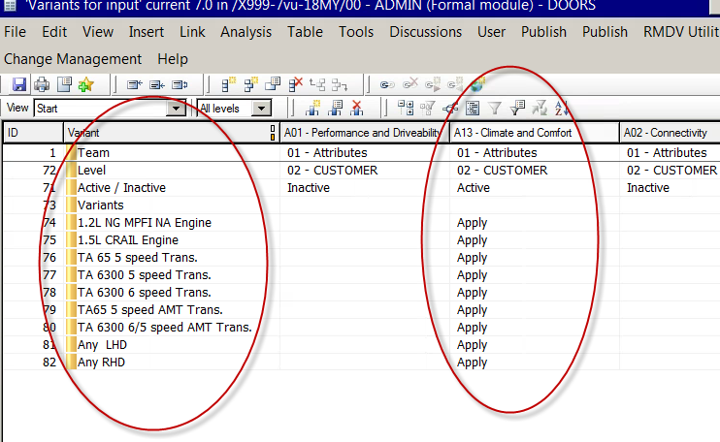

This is an example screenshot of the Variants for input module after importing the VPC.

1. Save and close the Variants for input module.

This step is now complete.

## Propagate the variant information to the Project Configuration

The variants imported in the previous step need to be propagated to the Project Configuration module in addition to the Any Vehicle default variant. The variant information will get added for each team in the project so if there are 10 active teams each with 10 variants plus the Any Vehicle, there will be 110 objects in the Project Configuration module.

1. Navigate to the 00 – ADMIN folder in thenew vehicle programme in DOORS.
2. Open the Project Configuration module in exclusive edit.
3. From the menu, select RMDV Utilities > RMDV Scripts > Admin > Add variant information to Configuration module

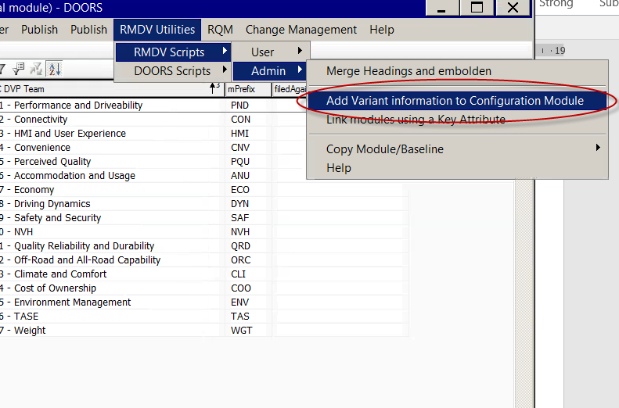

1. Verify that the script completes and that variant information is added to project configuration

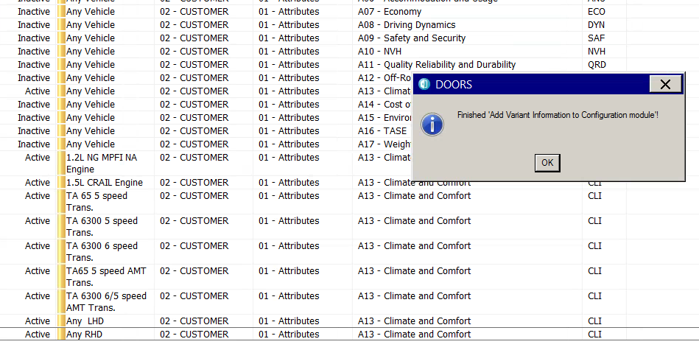

1. Save the Project Configuration module

This step is now complete.

## Add the RDS group prefix to Project Configuration

One of the important tasks needed to set the access rights correctly is the identification of the RDS group prefix. The RDS group prefix was done in section 3.7 where the xml file was edited to replace the existing project name with the new one. In that example, the new project was X999-7vu-18MY.

1. Navigate to the 00 – ADMIN folder in the new vehicle programme
2. Open the Project Configuration module in exclusive edit.
3. From the module menu, select File > Module Properties
4. Locate the entry ‘Group Name’

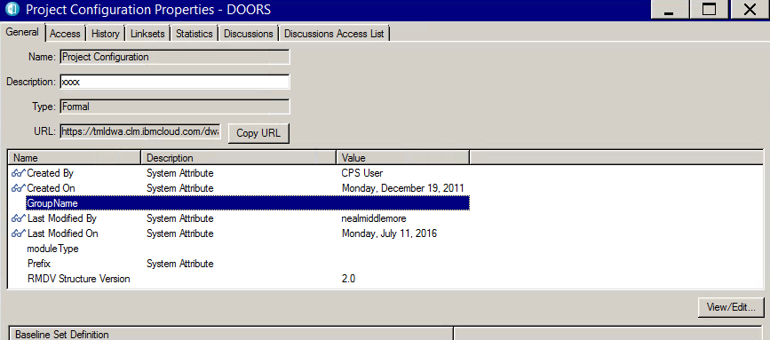

1. Either double click the entry or click the View/Edit button.
2. Enter the group name in to the box

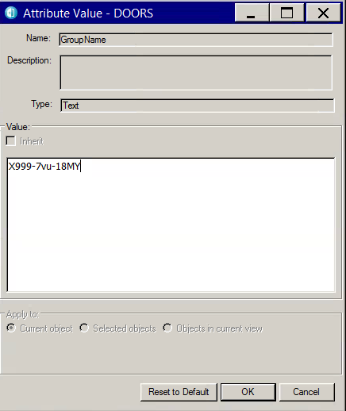

1. Click the OK button.
2. Click the OK button on the Module Properties dialogue box.
3. Save and close the Project Configuration module.

This step is now complete.

## Run ‘Programme Creation’

The final step in configuring the DOORS project correctly as an RMDV vehicle programme is to run the ‘Create the programme’ script. This script uses the Project Configuration module to identify all of the teams that are active in this vehicle programme. If a team is active, the variants are pushed to the module for that team and the triggers to synchronise with RTC are set. As soon as this occurs, every time a user closes a module from Exclusive Edit, the script will push correctly classified requirements to RTC with no further user input required.

The entire project also has the correct permissions set, this is based on the groups that were imported to RDS and the GroupName attribute in the Project Configuration module.

1. Ensure all modules are closed.
2. From the DOORS Database Explorer, select RMDV Utilities > Admin > Create the programme

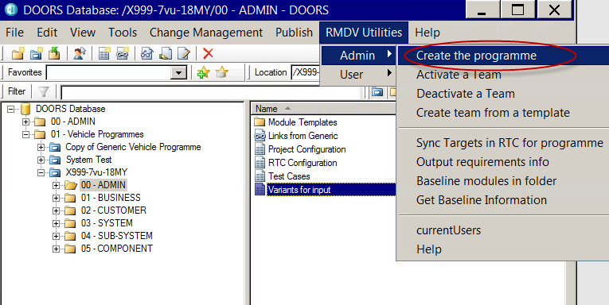

1. Select the correct programme from the list of available programmes.

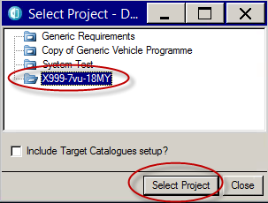

1. Leave the ‘Include Target Catalogues setup?’ box unticked, this not used in the TML RMDV instance.
2. Click the ‘Select Project’ button. – This will now process the project, the more levels/teams that are populated, the longer this will take.
3. Verify the process completes:

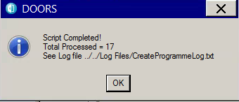

1. Click the OK button to finish running the script.
2. Go to the Windows Explorer from the Citrix Storefront.
3. Open the folder: X:\Log Files

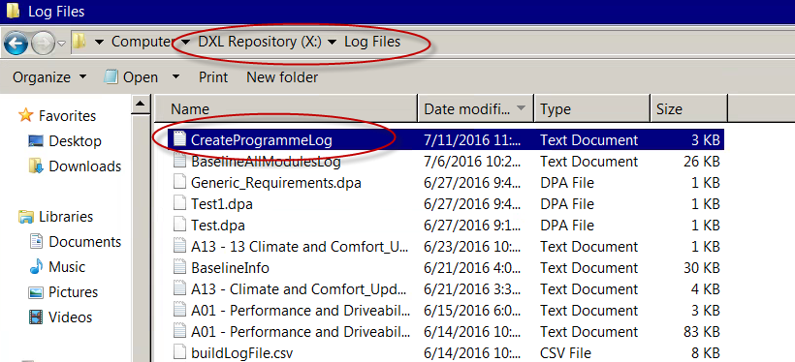

1. Open the CreateProgrammeLog.txt file and review it for errors:

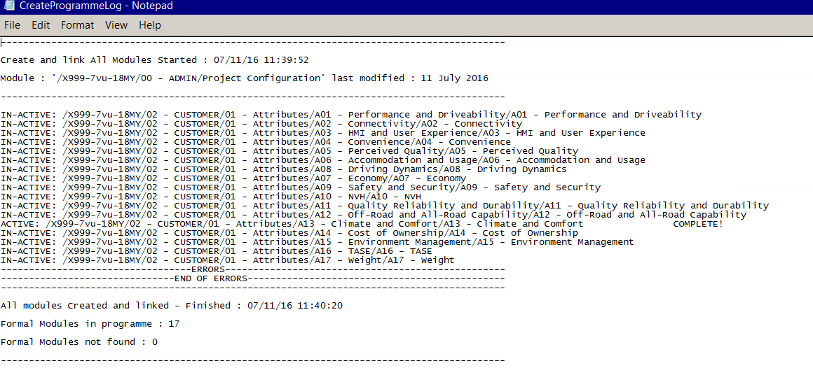

The log file lists the teams it has processed, if they are active or not and did it complete. If there are any errors then review them, correct the root cause and run the Create the Programme script again. There is no limit to the amount of times you can run this.

1. Close the log file.

This step is now complete

## Test to ensure the programme is set up correctly

### Test to ensure links to Generic Requirements are intact

In order to verify the programme set up is correctly completed, certain aspects need to be verified. The first is the linkage between Generic Requirements and the new vehicle programme, we need to verify that the requirements in the programme are linked to the generic requirements they are sourced from, that they are not linked to any other programmes and that the generic tests are correctly linked as well.

1. Open the 02 – CUSTOMER/01 – Attributes/A13 – Climate and Comfort/A13 – Climate and Comfort module.
2. Verify that the requirements have requirement IDs.
3. Verify the in-links are from generic requirements. – right click the orange triangle at the end of the requirement column.

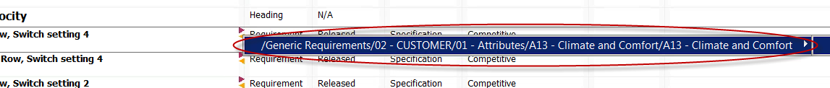

1. Verify the out-links are to the generic test cases (Validated by) – right click the red triangle at the end of the requirement column.



1. Verify that there are no out-links or in-links to other vehicle programmes (this is a symptom of copying the Generic Requirements module rather than archiving and restoring it).

This step is now complete

### Test to ensure access rights have been correctly applied.

In order to verify access rights are complete, it is assumed there were no error messages in the createprogramme log file about access groups.

As the scope of RMDV grows to encompass more teams than just the 17 attribute teams, it will be necessary to perform a random sampling of access rights.

1. Right click a formal module in one of the 02 – CUSTOMER/01 – Attributes teams.
2. Check the access rights are aligned to the process

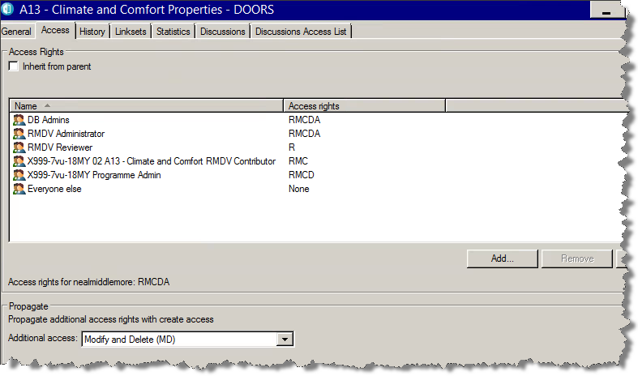

DB Admins and RMDV Administrators get full (RMCDA) access.

RMDV Reviewers get R

Programme-Team-RMDV Contributor get RMC

Programme-Programme Admin gets RMCD.

Additional access is set to Modify and Delete (MD).

This means that the team contributors group can open the module, change module attributes, create, modify and delete new requirements but cannot delete the module itself.

1. Close the access rights dialogue box.
2. Repeat steps 1-3 for other active teams.
3. Check the inactive teams have the correct access rights:

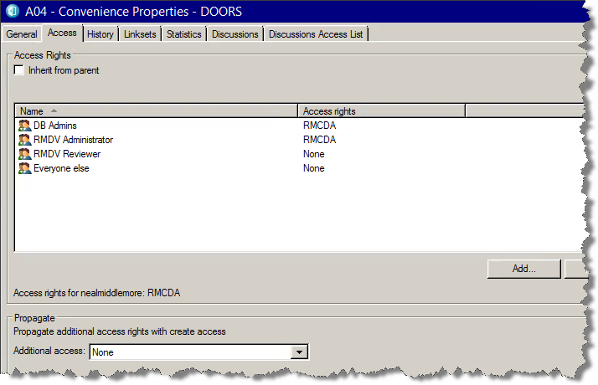

The only groups with any access to INACTIVE teams are DB Admins and RMDV Administrator.

This step is now complete.

### Test to ensure triggers have been applied correctly.

In order to test the integration triggers have been set up correctly, it is necessary to open a module in exclusive edit and then close it to see if it processes the trigger.

1. Open a random requirements module in an active team in exclusive edit
2. Switch to the 01 – Classification and Targets view
3. Choose a requirement, making a note of which one, and enter a value in VAR: Any Vehicle
4. Set the Classification drop down to MEET.
5. Close the module (File > Exit or Click the X in top right corner)
6. Verify the Step 1 of 2: Data Checking dialogue box is presented:

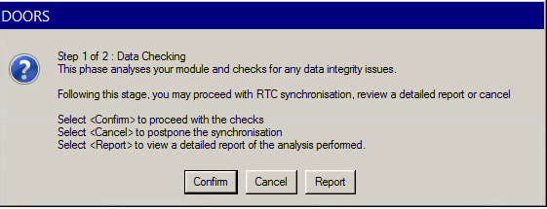

1. Click the Confirm button
2. Verify in Step 2 of 2 the dialogue box reports 1 req to be submitted to RTC

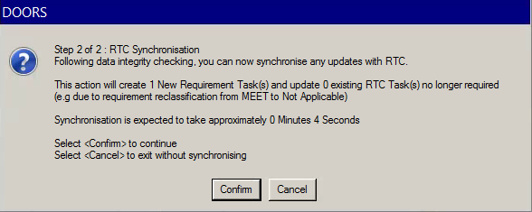

1. Click Confirm
2. If you have not logged in to RTC from DOORS during this session you will need to enter your username and password and click Log In:

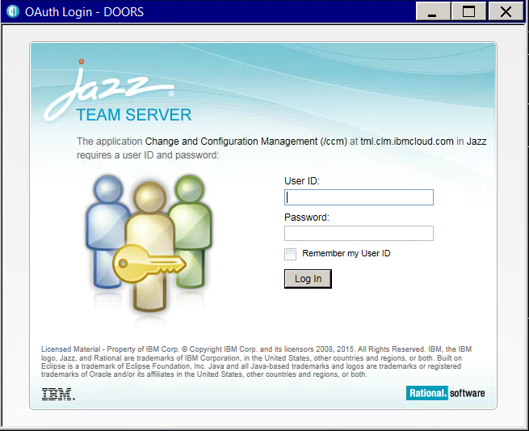

1. Verify the Finished Processing Module box is presented.

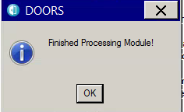

1. Click OK

This step is now complete.

### Test to ensure links to RTC work correctly

The final test is to check the links between DOORS and RTC have been created.

1. Open the DOORS module you used in the previous section to send a requirement to RTC
2. Navigate to the requirement you sent to RTC
3. Turn of the Filter to show the variants.

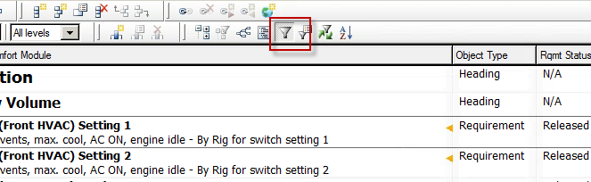

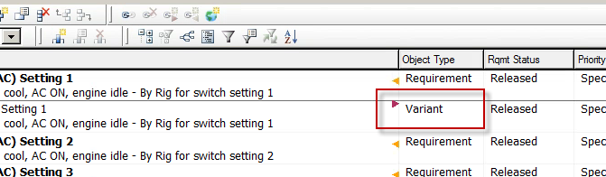

1. Right click on the red triangle next to variant to show the work item ID in RTC.

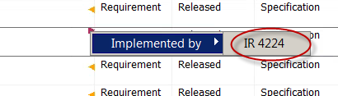

1. Open RTC and go to the new programme.
2. In the top right corner, search for the work item ID from step 4 (i.e. 4224)

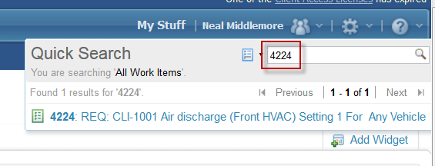

1. Press return to open the new work item
2. Verify the REQ id in the title line matches the one that you sent.
3. Verify the target and other information is correct
4. Verify the requirement is linked at the bottom of the page. Note the requirement link will show the unique ID rather than the generic ID. Hover over the link to see the full information.

This step is now complete.

### Clean up test requirements.

The test requirement you sent to RTC needs to be removed as it is the engineer’s job to do this.

1. In the DOORS module, turn off the filter to show the variants.
2. Delete the variant in DOORS.
3. Select View > Show > Deletions
4. Right click the deleted variant (red text, black change bar) and select Purge

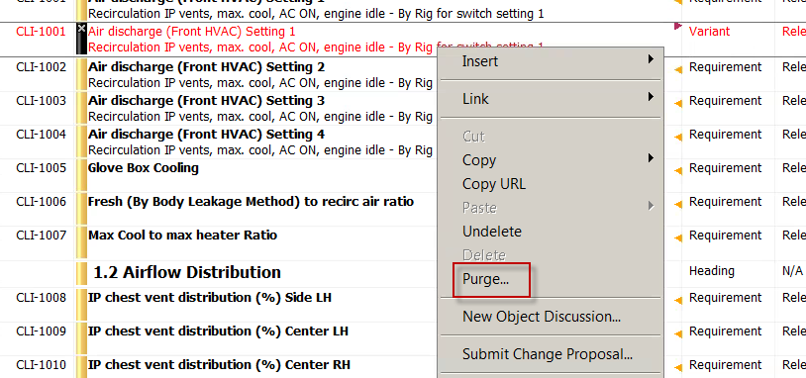

1. Select ‘Confirm’ to complete the Purge.
2. Delete the value you entered in the VAR: Any Vehicle attribute for the requirement.
3. Set the requirement Classification back to default.

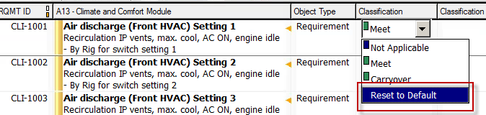

1. Save and close the module. (There should not be anything to send to RTC)
2. Go to the work item in RTC.
3. In the top right corner, select the red X icon to delete the work item:

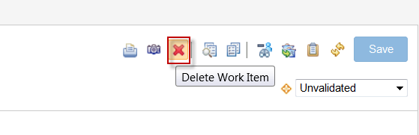

1. Click OK to confirm the deletion.

This step is now complete.

## Restore access rights

The final step is to restore access rights at the top level, this will make the project visible to the non-admin teams.

1. In the DOORS Database Explorer, navigate to the new vehicle programme.
2. Right click the new vehicle programme and select Properties:

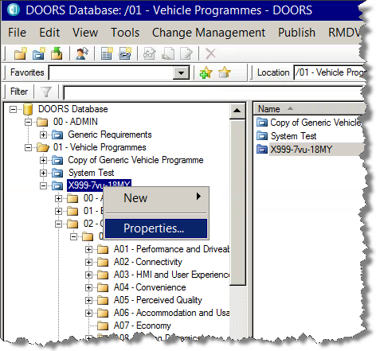

1. Switch to the Access tab:

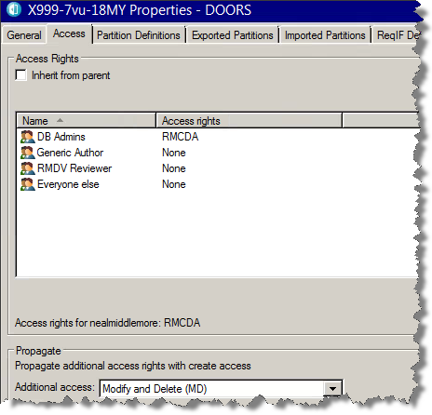

1. Select Generic Author
2. Select Edit
3. Set the permissions to Read:

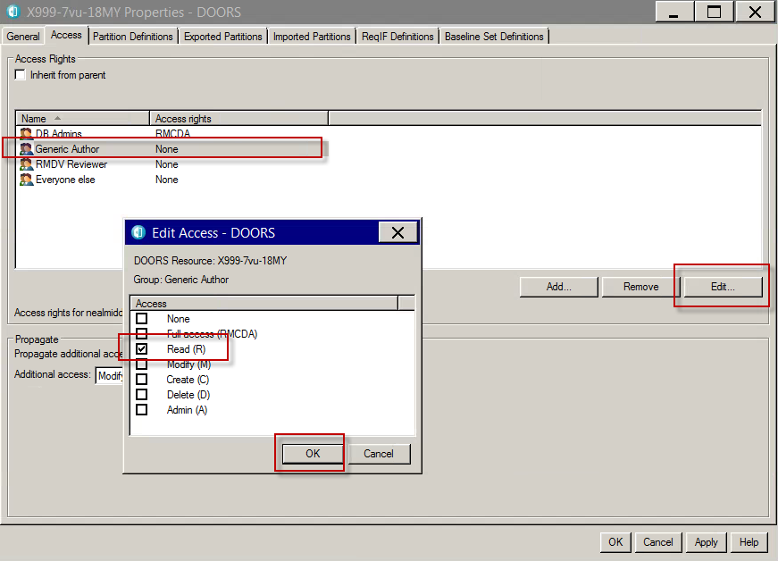

1. Select OK on the Edit Access dialogue.
2. Repeat steps 5 and 6 for the RMDV Reviewer group.
3. Select OK on the project properties dialogue. (Note: Everyone Else should be set to None).

This step is completed.

The new programme is now setup.

# User Groups

All access rights in RMDV DOORS Database are set by groups, UNDER NO CIRCUMSTANCES SHOULD AN INDIVIDUAL USER BE ADDED TO ACCESS RIGHTS.

## DB Admins

The DB Admins group can administer a Vehicle Programme and will have responsibility for running all necessary DXL code to instantiate and configure a new vehicle programme from scratch. Will also be responsible for managing the list of actors and applying to the appropriate roles within the project as well as configuration of all active modules for linking to RTC.

## Generic Author

The Generic Authors group has right access to the generic requirements project that forms the basis of all vehicle projects. Users that are authorised to modify generic requirements should be made members of this group.

## RMDV Administrator

The RMDV Administrator group has less permissions that the DB Admins group but can still run all of the DXL required to set up a new vehicle programme. Typically, the RMDV Administrators are members of the Vehicle Engineering team. Normally the DB Admins team does all of the initial setup and the RMDV Administrators might activate new teams as the needs of the programme evolve.

## Program Admin

The Programme Admin user group is responsible for administering a Vehicle Programme. This will usually involve helping a user to correct issues they may have created. The programme admin group has more access rights than a RMDV Contributor group.

## RMDV Contributor

The Contributor user group is responsible for writing vehicle specific requirements in the requirements modules, and for classifying requirements and setting targets against generic requirements, and creating the traceability from component requirements to system requirements, from system requirements to customer requirements, etc.

Any member of a Contributor user group will also have read access to ALL other modules within the same vehicle programme (by virtue of membership of the RMDV Reviewer group). However, they will not have modified access to the generic requirement text, just the attributes.

## RMDV Reviewer

The Reviewer user group is a role that will allow engineers who are not responsible for authoring requirements to be able to view the content. The ability to view requirements will be limited to the vehicle project for which they are approved for access only.

# DXL

The RMDV solution in DOORS relies heavily on DXL scripts. This section lists the scripts used with a brief description of what it does.

## Project Addins

Project Addins are scripts that are run from the DOORS Database Explorer, as such they do not rely on a specific module being open, however they might rely on being able to get exclusive access to a particular module.

### User addins

|  |  |
| --- | --- |
| Title | Description |
| Reports scripts | These scripts have not been tested due to a lack of MS Excel in the environment. These scripts are JLR standard and have not been modified. |
| Find Requirement | Only works within a vehicle programme, it allows a user to see all copies of a specific requirement. |

### Admin addins

|  |  |
| --- | --- |
| Title | Description |
| Create the programme | Performs all of the programme setup such as setting access rights etc assuming the Project Configuration module has been fully set up. This script can be run as many times as needed. Creates a log file. |
| Activate a team | Does the same thing as Create the programme but just for a specific team. Creates a log file. |
| Deactivate a team | If a team is no longer needed in a vehicle programme, this script can be run to set the module inactive and remove the access rights to the standard set of access rights for inactive teams. Creates a log file. |
| Create team from a template | If a running vehicle programme needs a team to be added that DID NOT exist when the programme was created, this script will add the team by using the template modules in the 00 – ADMIN area of the programme. It is important, therefore, to ensure that any attribute changes that are made to requirements modules in the Generics, the same changes are made to the template modules. |
| Sync targets in RTC for programme | The admin user has the option of forcing a synchronisation of ALL targets for all requirements in all of the teams in the vehicle programme. This might be performed prior to a gateway to ensure the latest information is available. It also means that engineers cannot hide target updates. |
| Output Requirement Info | This script creates a csv file with information from every requirements module in the entire project. |
| Baseline modules in folder | This script baselines the modules, it is used to baseline all of the modules in the Generic Requirements project. |
| Get Baseline info | This gets the baseline versions of all the modules in the programme. It creates a log file with the output. |
| Current users | Prints a list of current users that are logged in. |

## Module Addins

Module addins provides a set of menu options inside a module.

### Admin addins

|  |  |
| --- | --- |
| Script | Description |
| Merge headings and embolden | This merges the RTC Title attribute with the requirement text to make the object appear as:  **RTC Title Text**  The requirement text…. |
| Update all TC from links | This is a TML specific script. It looks at the outgoing external links (which will only go to RQM) and updates the test case IDs and titles in every object. Typically use it in generic requirements modules following test case updates. |
| Add variant information to configuration module | This script has to be run from the Project Configuration module, it will add rows for each team – variant combination. |
| Link modules by key attribute | This is more of a generic admin function than an RMDV specific one. It will create links from one module to another based on the contents of a specific attribute in each module. |
| Copy Baseline preserve IDs | This again is a generic DOORS admin script rather than RMDV specific, it will copy a baseline of a specific module and maintain the IDs (as opposed to the native functionality which will renumber from 1) |
| Copy views | This is used to manage consistency of views across modules. Typically used in Generic requirements projects where views get changed in one module and need to be propagated to other modules without doing each one manually. |

### User Addins

|  |  |
| --- | --- |
| Script | Description |
| Sync requirements | Manually initiates the module checking process and sends all requirements that need to be sent to RTC. This is the same functionality that is triggered automatically when closing the module. |
| Add variants to Classification view | This is a TML specific script. This script adds all of the VAR: type attributes to the 01 – Classification and Targets view. It has a limit of 25 variants which is the DOORS limit of 32 columns and includes the core 7 columns. The user can manually modify the view if needed. |
| Update Test Case for this Requirement | This is a TML specific script. It allows the user to update the test case ID and title automatically from the links to RQM. This is typically done when the user adds a programme specific requirement and test case. |
| Module Metrics | This script presents the user with a graph that shows the number of requirements in what state of classification. |
| Update targets in RTC | Allows the engineer to update the targets in RTC for all of the requirement/variants in the module. Can be forced by the Admin script if needed. |

### Non-RMDV specific addins

In the RMDV Utilities menu in a module, there is a section called DOORS Scripts. The scripts in here are not needed by RMDV but provide some generic DOORS capabilities. The scripts are all JLR standard and have not been tested for TML.